# **COMPUTER COMMUNICATION AND NETWORKS**

# **LAB 02**

|  |  |
| --- | --- |
| **LAB TITLE** *Networking Basics: Learn to use different network commands* | |
| **Lab Objectives** | *To practice basic network commands.* |
| **Lab Task/Experiment** | *Search out any 5 network commands and explain.* |
| **Equipment** | *Command Prompt* |

**Statement Purpose:**

Learn to use the different network commands.

**Procedure:**

To do this lab follow the steps:

Use the Start menu to open the Command Prompt, an MS-DOS-like window.

Press **Start** > **Programs** > **Accessories** > **Command Prompt**

OR

**Start** > **Programs** > **Command Prompt**.

OR

**Press Start>Run Then type cmd.**

Type following commands and press the Enter key.

1. **IPCONFIG**

**PURPOSE:**

*ipconfig* ([internet protocol](http://en.wikipedia.org/wiki/Internet_protocol) configuration) in [Microsoft Windows](http://en.wikipedia.org/wiki/Microsoft_Windows) is a [console application](http://en.wikipedia.org/wiki/Console_application) that displays all current [TCP/IP](http://en.wikipedia.org/wiki/TCP/IP) network configuration values and refreshes Dynamic Host Configuration Protocol [DHCP](http://en.wikipedia.org/wiki/DHCP) and Domain Name System [DNS](http://en.wikipedia.org/wiki/Domain_name_system) settings. Used without parameters, ipconfig displays the IP address, subnet mask, and default gateway for all adapters.

**PROPERTIES**

Windows IP Configuration

Ethernet adapter Local Area Connection:

|  |  |
| --- | --- |
| Media State . . . . . . . . . . . : | Media disconnected |
| Ethernet adapter Local Area Connection 2: |  |
| Connection-specific DNS Suffix . : |  |
| Autoconfiguration IP Address. . . : | 169.254.190.99 |
| Subnet Mask . . . . . . . . . . . : | 255.255.0.0 |
| Default Gateway . . . . . . . . . : |  |
| PPP adapter My ISP: |  |
| Connection-specific DNS Suffix . : |  |
| IP Address. . . . . . . . . . . . : | 58.65.188.107 |
| Subnet Mask . . . . . . . . . . . : | 255.255.255.255 |
| Default Gateway . . . . . . . . . : | 58.65.188.107 |

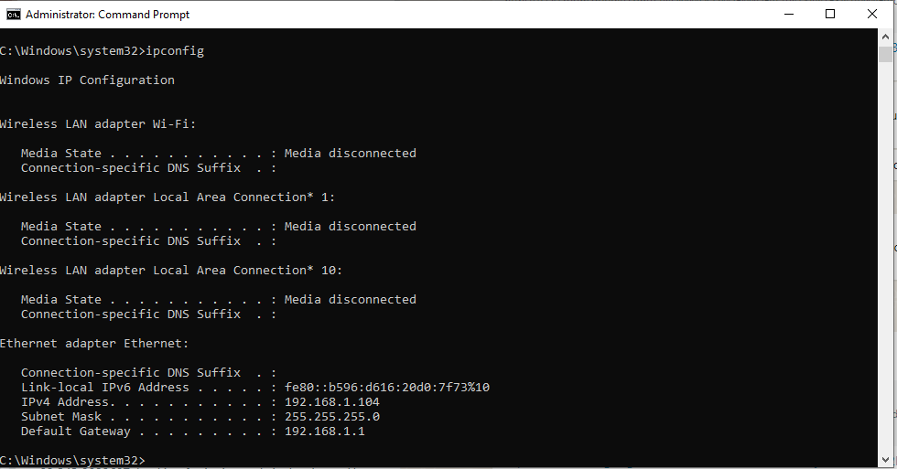

***Fig 1:*** Successful Result of ipconfig

**Note:**

The IP address and the default gateway should be in the same network, otherwise this host would not be able to communicate outside the network. In Fig. 1, the subnet mask tells us that the first three octets of the IP address and the default gateway must be the same to be in the same network.

1. **IPCONFIG /ALL**

**PURPOSE:**

Display full configuration information.

**0BSERVATION**

**WINDOWS IP CONFIGURATION:**

|  |  |
| --- | --- |
| Host Name . . . . . . . . . . . . : | DESKTOP-QU25GOP |
| Primary Dns Suffix . . . . . . . : |  |
| Node Type . . . . . . . . . . . . : | Hybrid |
| IP Routing Enabled. . . . . . . . : | No |
| WINS Proxy Enabled. . . . . . . . : | No |

**ETHERNET ADAPTER LOCAL AREA CONNECTION:**

|  |  |
| --- | --- |
| Media State . . . . . . . . . . . : | Media disconnected |
| Description . . . . . . . . . . . : | 802.11n USB Wireless LAN Card |
| Physical Address. . . . . . . . : | 20-E8-17-07-D0-AA |

**ETHERNET ADAPTER LOCAL AREA CONNECTION 2:**

|  |  |
| --- | --- |
| Connection-specific DNS Suffix . : |  |
| Description . . . . . . . . . . . : | Realtek PCIe GbE Family Controller |
| Physical Address. . . . . . . . . : | 18-C0-4D-6D-7D-00 |
| Dhcp Enabled. . . . . . . . . . . : | Yes |
| Autoconfiguration Enabled . . . . : | Yes |
| Autoconfiguration IP Address. . . : | 192.168.1.104(Preferred) |
| Subnet Mask . . . . . . . . . . . : | 255.255.255.0 |
| Default Gateway . . . . . . . . . : | 192.168.1.1 |

**PPP ADAPTER MY ISP:**

|  |  |
| --- | --- |
| **Connection-specific DNS Suffix . :** | |
| Description . . . . . . . . . . . : | WAN (PPP/SLIP) Interface |
| Physical Address. . . . . . . . . : | 00-53-45-00-00-00 |
| Dhcp Enabled. . . . . . . . . . . : | No |
| IP Address. . . . . . . . . . . . : | 58.65.190.44 |
| Subnet Mask . . . . . . . . . . . : | 255.255.255.255 |
| Default Gateway . . . . . . . . . : | 58.65.190.44 |
| DNS Servers . . . . . . . . . . . : | 203.82.48.4 |
|  | 58.65.175.74 |

1. **PING**

**PURPOSE**

Ping is a [computer network](http://en.wikipedia.org/wiki/Computer_network) administration utility used to test whether a particular [host](http://en.wikipedia.org/wiki/Host_(network)) is reachable across an [Internet Protocol](http://en.wikipedia.org/wiki/Internet_Protocol) (IP) network and to measure the [round-trip time](http://en.wikipedia.org/wiki/Round-trip_time) for packets sent from the local host to a destination computer. Ping operates by sending [Internet Control Message Protocol](http://en.wikipedia.org/wiki/Internet_Control_Message_Protocol) (ICMP) echo request [packets](http://en.wikipedia.org/wiki/Packet_(information_technology)) to the target host and waits for an ICMP response. In the process it measures the round-trip timeand records any [packet loss](http://en.wikipedia.org/wiki/Packet_loss). The results of the test are printed in form of a statistical summary of the response packets received.

**OBSERVATION**

Usage: ping [-t] [-a] [-n count] [-l size] [-f] [-i TTL] [-v TOS] [-r count] [-s count] [-w timeout] target_name

**OPTIONS:**

|  |  |
| --- | --- |
| -t | Using this option will ping the *target* until you force it to stop using Ctrl-C. |
| -n count | This option sets the number of ICMP Echo Requests to send, from 1 to 4294967295. The ping command will send 4 by default if **-n** isn't used. |
| -l size | Use this option to set the size, in bytes, of the echo request packet from 32 to 65,527. The ping command will send a 32-byte echo request if you don't use the **-l** option. |
| -f | Use this ping command option to prevent ICMP Echo Requests from being fragmented by routers between you and the target. |
| -i TTL | This option sets the Time to Live (TTL) value, the maximum of which is 255. |
| -r count | Use this ping command option to specify the number of hops between your computer and the target computer or device that you'd like to be recorded and displayed. |
| -s count | Timestamp for count hops. |
| -w timeout | Specifying a timeout value when executing the ping command adjusts the amount of time, in milliseconds, that ping waits for each reply. If you don't use the **-w** option, the default timeout value of 4000 is used, which is 4 seconds. |

Ping the IP address of another computer. Note that for the ping and tracert commands to work the PC firewalls have to be disabled.

Ask the IP address of the workstation that is being used by another group of students. Then type ping, space, and the IP address that you received, then press Enter. Notice the outputs.

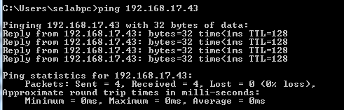

***Fig. 2***: Successful result of a ping to a certain IP address.

Ping the IP address of the gateway router from the details that have been observed in the output of step above. If the ping is successful, it means that there is a physical connectivity to the router on the local network and probably the rest of the world.

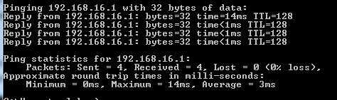

**ping the Loopback IP address of this computer**

Type the following command: ping 127.0.0.1

The 127.0.0.1 network is reserved for loopback testing. If the ping is successful, then TCP/IP is properly installed and functioning on this computer.

Was the ping successful?

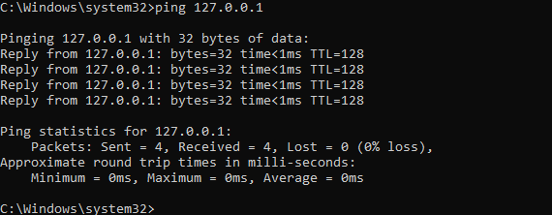

You can also ping using names like websites. Ping the IP address of the NUML website. Type ping space and www.numlrwp.numl.edu.pk or www.google.com then presses Enter. Notice the outputs. A DNS server will resolve the name to an IP address and the ping will be successful only in the existence of the DNS server.

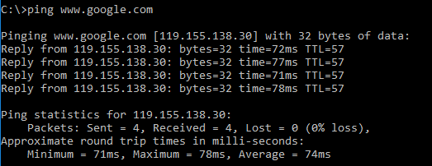

1. **Traceroute**

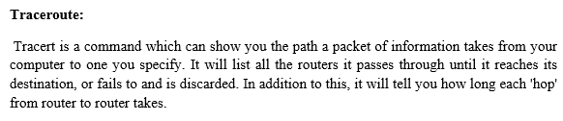

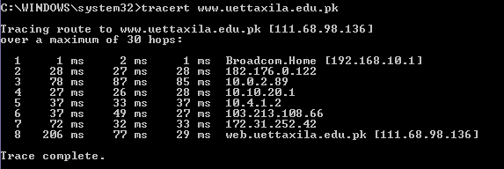

Type **tracert www.google.com** and press **Enter**.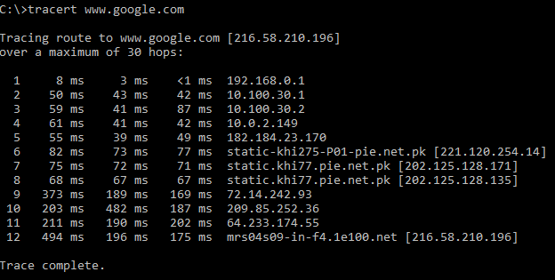

**Trace a local host name or IP address**

Try using the tracert command with a local host name or IP address. It should not take long because the trace does not pass through any routers.

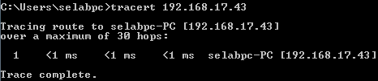

**What is difference between TRACERT and PATHPING?**

**Tracert:**

A communication failure occurs when a connection on a route breaks down on the way from the source computer to a destination computer. In this situation, a command-line utility called TRACERT is used that helps the user to figure out the exact location along the route where the problem has occurred.

**Pathping:**

The PATHPING command is similar to the TRACERT command. Besides executing the task performed by TRACERT, the PATHPING command also provides the information about data loss between the source computer and the destination computer.

1. **ARP**

Displays and modifies entries in the Address Resolution Protocol (ARP) cache, which contains one or more tables that are used to store IP addresses and their resolved Ethernet or physical addresses. There is a separate table for each Ethernet or Token Ring network adapter installed on your computer. Used without parameters, arp displays help.

Type **arp –a** in cmd ,this command handles the resolution of a IP to a physical address. The

command gives a list of IPs and physical addresses on your local network

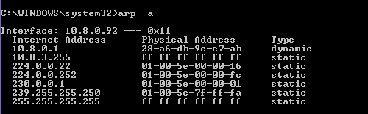

1. **NSLOOKUP**

**PURPOSE**

*nslookup* is a [computer program](http://en.wikipedia.org/wiki/Computer_program) used in [Windows](http://en.wikipedia.org/wiki/Microsoft_Windows) to query [Domain Name System](http://en.wikipedia.org/wiki/Domain_Name_System) (DNS) servers to find DNS details, including [IP addresses](http://en.wikipedia.org/wiki/IP_address) of a particular computer.

The *nslookup* command enters interactive mode when no arguments are given, or when the first argument is a - (minus sign) and the second argument is the host name or Internet address of a name server. When no arguments are given, the command queries the default name server.

**SUBCOMMANDS**

Nslookup has the subcommands:

1. server NAME (where NAME is the name or IP address of a DNS server to query). It is not always possible to query a specific DNS server as often DNS queries are blocked to prevent denial of service attacks.
2. set type=NAME (where NAME is the type of record to look at). For example, set type mx will give the mail records.

**OBSERVATION**

Default Server: ns3.dsl.net.pk

Address: 203.82.48.236

Type **Nslookup** in cmd and then the address of a website. With this tool, you can check your DNS

servers. For example, imagine you are experiencing a problem with your current DNS and it cannot resolve the address. You can test it with nslookup and use other DNS servers to try to resolve the address. Type nslookup space www.google.com and press enter.

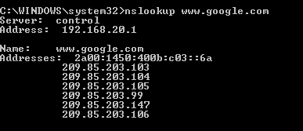

**ipconfig /displaydns** shows the content of the dns cache . to clear it type **ipconfig /flushdns**.

# **NETSTAT**

**PURPOSE**

*netstat* (network statistics) is a [command-line](http://en.wikipedia.org/wiki/Command_line_interface) [tool](http://en.wikipedia.org/wiki/Computer_software) that displays [network connections](http://en.wikipedia.org/wiki/Transmission_Control_Protocol) (both incoming and outgoing), routing tables, and a number of network interface statistics. It is available on [Unix](http://en.wikipedia.org/wiki/Unix), and windows-based [operating systems](http://en.wikipedia.org/wiki/Operating_systems)It is used for finding problems in the network and to determine the amount of traffic on the network as a performance measurement.

**SUBCOMMANDS**

*netstat* provides statistics for the following:

* Proto - The name of the protocol ([TCP](http://en.wikipedia.org/wiki/Transmission_Control_Protocol) or [UDP](http://en.wikipedia.org/wiki/User_Datagram_Protocol)).
* Local Address - The [IP](http://en.wikipedia.org/wiki/Internet_Protocol) address of the local computer and the port number being used. The name of the local computer that corresponds to the [IP](http://en.wikipedia.org/wiki/Internet_Protocol) address and the name of the port is shown unless the **-n** parameter is specified. If the port is not yet established, the port number is shown as an asterisk (*).
* Foreign Address - The [IP](http://en.wikipedia.org/wiki/Internet_Protocol) address and port number of the remote computer to which the socket is connected. The names that corresponds to the [IP](http://en.wikipedia.org/wiki/Internet_Protocol) address and the port are shown unless the **-n** parameter is specified. If the port is not yet established, the port number is shown as an asterisk (*).
* State - Indicates the state of a [TCP](http://en.wikipedia.org/wiki/Transmission_Control_Protocol) connection.

**PROPERTIES**

|  |  |  |  |
| --- | --- | --- | --- |
| **PROTO** | **LOCAL ADDRESS** | **FOREIGN ADDRESS** | **STATE** |
| TCP | 3c3818552cab455:1027 | localhost:2001 | ESTABLISHED |
| TCP | 3c3818552cab455:1073 | localhost:1074 | ESTABLISHED |
| TCP | 3c3818552cab455:1074 | localhost:1073 | ESTABLISHED |
| TCP | 3c3818552cab455:1075 | localhost:1076 | ESTABLISHED |
| TCP | 3c3818552cab455:1076 | localhost:1075 | ESTABLISHED |
| TCP | 3c3818552cab455:2001 | localhost:1027 | ESTABLISHED |

# **COMPUTER COMMUNICATION AND NETWORKS**

# **LAB 02**

***LAB Title: Networking Basics: Learn to use different network commands***

**Lab Task: Search out any 5 commands other than these and explain.**